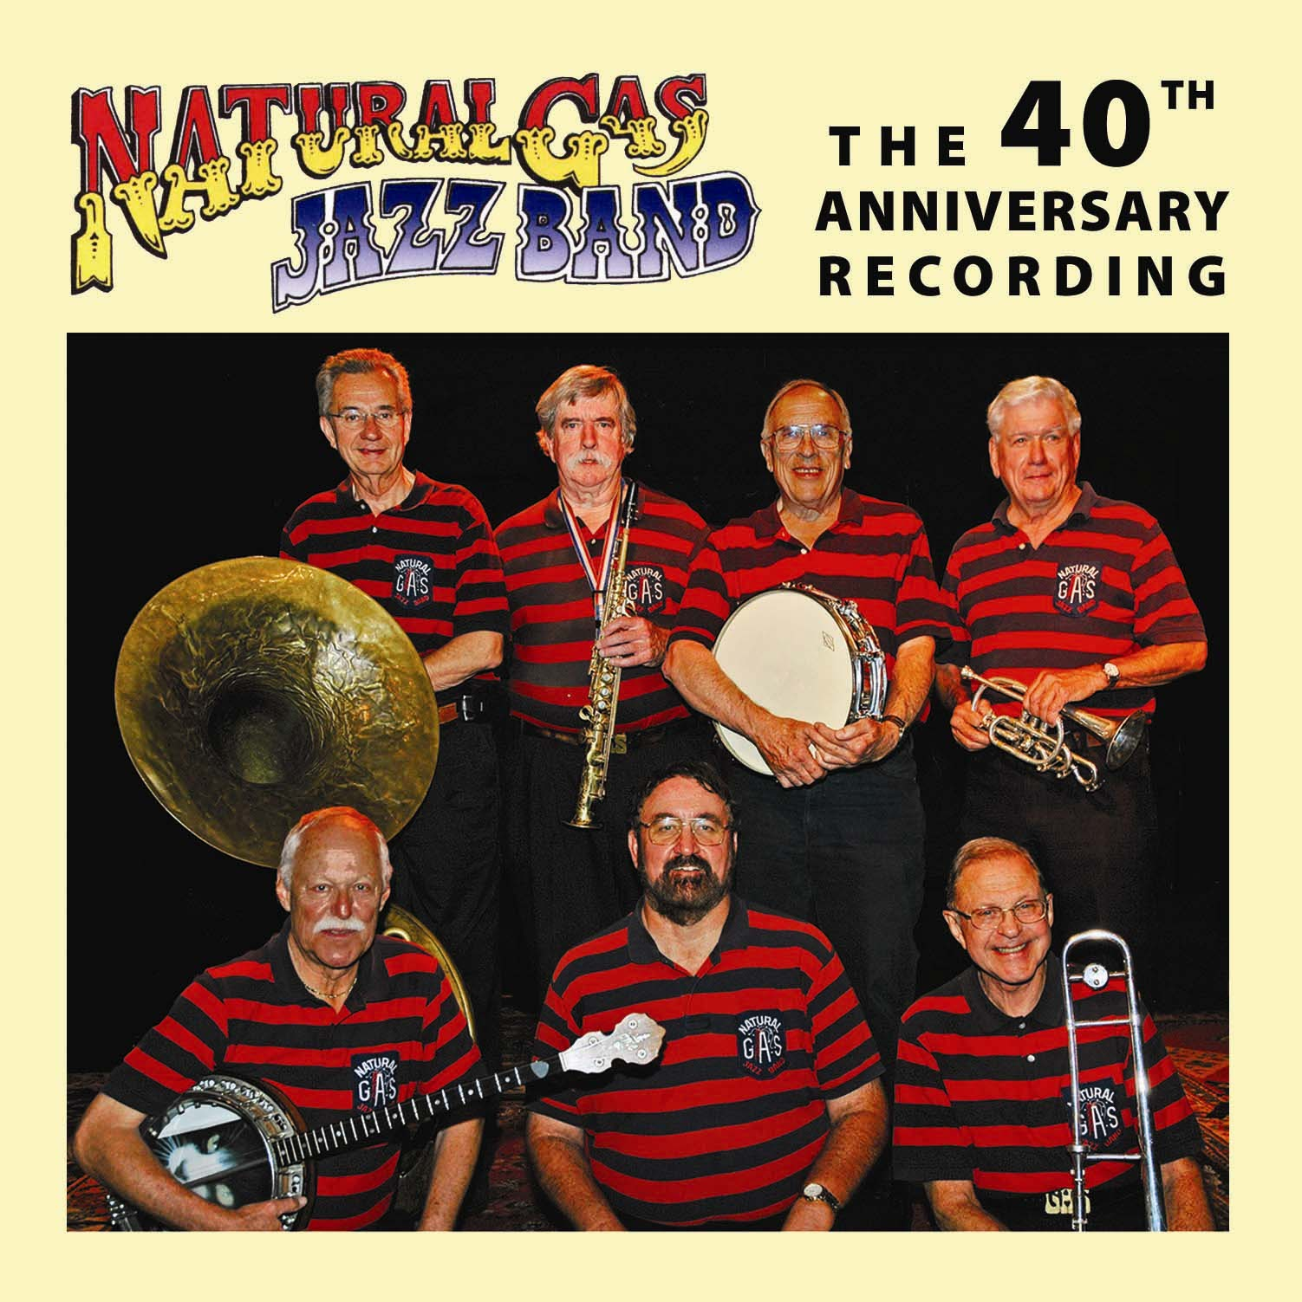
NATURAL GAS
JAZZ BAND PROUDLY ANNOUNCES THE RELEASE OF THE NEW CD

“This new CD is terrific! It is an outstanding statement of the present band’s happy, goodtime sounds. What could be better than to have such a band in this fast changing world where good musical taste is becoming so rare? So, let’s get out the parasols and start celebrating the next 40 years!”
D. O., May 2009

Unlike many traditional jazz bands, the NGJB favors selections which may not be a part of the average musical menu.
Here spirited numbers such as Stevedore Stomp, Willie the Weeper, My Memphis Baby, and Goin’ Home provide an opportunity for the band to cut loose a bit.
Several blues selections, including Alcoholic Blues, Sobbin’ Blues, Terrible Blues, and Redman Blues go to the root of New Orleans jazz. In Alcoholic, Carl Lunsford’s vocal bespeaks mankind’s struggle with drink. Jim Brennan’s tuba solo in Terrible is truly a classic. And, Redman is a “down and dirty” gut wrencher. Sobbin’ nicely rounds out the blues spectrum with its haunting melodic patterns.
Bob Murphy’s soprano sax treatment of Flamingo is a somewhat more modern offering but it gives one a chance to hear this artist in a mellow mood.
No jazz recording is worth its salt without some downright danceable music. Down Where the Sun Goes Down tickled the toes of old Firehouse Five listeners. Megametz, which pianist Ed Metz, Sr. wrote for his Revelers group, and Cabin in the Pines, once a Louis Armstrong vocal, will also get you out on the dance floor with your honey.
I Double Dare You gives Phil Crumley a chance to warble to you as does Goin’ Home where Bill Carson joins him on the vocal.
The band’s professor on the piano, Rich Owens, is often featured on this disc, but he sings too on Float Me Down the River and then Deed I Do, where his piano solo and vocal are backed up by the tasty banjo work of Carl Lunsford, Jim Brennan’s tuba, and the drumming of Warren Perry.
--------------------------------------------------------------------------

$17, postage paid. Send order to: Natural Gas Jazz Band
26 Martling Drive
San Anselmo, CA 94960

NAME __________________________________________________

ADDRESS_________________________________________________

________________________________________________

